**First Capstone Project Proposal**

Project Idea 1: Maximizing fleet efficiency for a bike share company in Washington, D.C.

PROPOSAL DETAILS

1. **What is the problem you want to solve?**

Improve management & efficiency of bicycle sharing business in Washington, D.C.

1. *Summarize spatial movement of fleet*
2. *Define high and low demand times*
3. *Improve fleet management (e.g. placement of bikes or planning maintenance) based on spatial demand & usage*
4. *Predict user type (registered vs. casual) based on time of day or week*
5. **Who is your client and why do they care about this problem? In other words, what will your client DO or DECIDE based on your analysis that they wouldn’t have otherwise?**

The client is Capital Bikeshare, and will be able to understand spatial movement and usage patterns of their fleet, and improve efficiency by ensuring bikes are where they need to be when in demand, and maintenance is occurring at the most opportune times (preventing dissatisfied customers).

1. **What data are you going to use for this? How will you acquire this data?**

Capital Bikeshare posts quarterly data reports of bike trip times, start and end locations, and type of user (registered or casual). Each trip is on one line of data. These data are readily and publicly available at <https://www.capitalbikeshare.com/system-data>. The data look like this:

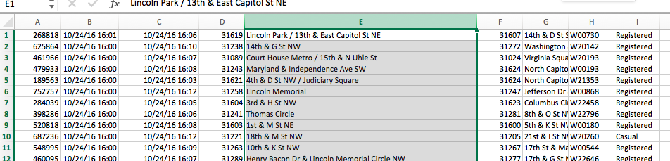

1. **In brief, outline your approach to solving this problem (knowing that this might change later).**

I intend to visualize the data using mapping techniques, and hope to develop some schematics to represent fleet movement. Histograms indicating high and low demand times at the various bike storage locations will help to develop more thorough analysis such as predicting user type based on time of use.

1. **What are your deliverables? Typically, this would include code, along with a paper and/or a slide deck.**

The final products will include code generalized for use with any quarterly report of bike usage data, as well as a slide presentation to describe the methods and benefits to Capital Bikeshare.